Skills
Balance a skeleton equation for a redox reaction by considering the half equations
Comparison of the renewability of energy sources
Application of calorimetry to measure energy changes
Question relating to an experimental context that is less familiar to students.
Application of faraday’s laws
Calibration of a calorimeter
Effects of heat loss in calorimetry
Use of the electrochemical series to check the possibility of a redox reaction
Predictions based on electrochemical series assuming standard conditions
Role of half equations in electrochemistry calculations
Writing half equations using single direction arrows
Awareness that oxidation occurs at the anode and reduction at the cathode (always)
Stating correct terms for oxidant and reductant (eg. Na⁺ or sodium cation is an oxidant, not sodium)
Role of electrolytes in electrochemical cells
Role of membranes in fuel cells
Converting mA to A (x10⁻³), converting time from hours to seconds (x60x60)

1 |  | A |  | B |  | C |  | D
2 |  | A |  | B |  | C |  | D
3 |  | A |  | B |  | C |  | D
4 |  | A |  | B |  | C |  | D
5 |  | A |  | B |  | C |  | D
6 |  | A |  | B |  | C |  | D
7 |  | A |  | B |  | C |  | D
8 |  | A |  | B |  | C |  | D
9 |  | A |  | B |  | C |  | D
10 |  | A |  | B |  | C |  | D
11 |  | A |  | B |  | C |  | D
12 |  | A |  | B |  | C |  | D
Section A - Multiple choice

Use the following information for Questions 1 and 2
Wind turbines capture wind energy within the area swept by their blades. They produce a power output proportional to the air density and the wind speed cubed. The spinning blades drive an electrical generator that produces electricity for export to the grid.
Question 1
The energy transformations that occur when a wind turbine is generating energy are:
A. | mechanical energy electrical energy
B. | kinetic energy thermal energy mechanical energy electrical energy
C. | kinetic energy mechanical energy electrical energy
D. | mechanical energy kinetic energy mechanical energy electrical energy

Question 2
Energy that is generated from wind turbines is considered to be:
A. | Sustainable because it is produced by a resource that will not run out
B. | Renewable because it produces no/little CO₂ emissions
C. | Non-renewable because the wind turbines are noisy and visually awful
D. | Renewable because it is a reliable source of energy

Question 3
A cell that is popular in military uses is the cell formed from the reaction of lithium and sulfur dioxide. The cell is expensive but is capable of producing a voltage of almost 3 volts. The overall equation for this cell is:
2Li + 2SO₂ Li₂S₂O₄
In this reaction, the oxidation number of sulfur:
A. | remains unchanged
B. | changes from +2 to +4
C. | changes from +4 to +6
D. | changes from +4 to +3
Question 4
For the galvanic cell consisting of Fe²⁺/Fe and Zn²⁺/Zn, the standard cell potential is
A. | 0.57 V with a positive Fe electrode
B. | 0.57 V with a positive Pb electrode
C. | 0.31 V with a positive Fe electrode
D. | 0.31 V with a positive Pb electrode
Question 5
When considering the following reactions:
1) S (s) + O₂ (g) SO₂ (g) ΔH = -297.0 kJ mol⁻¹
2) SO₂ (g) + ½ O₂ (g) SO₃ (g) ΔH = -98.0 kJ mol⁻¹
3) S (s) + 1 ½ O₂ (g) SO₃ (g)
The ΔH for Equation 3 would be
A. | - 395 kJ mol⁻¹  -297 – 98 = -395 kJ mol⁻¹ The total energy is the algebraic sum of the heats of any sequence of reactions that yield the reaction in question.
B. | + 395 kJ mol⁻¹
C. | - 199 kJ mol⁻¹
D. | + 199 kJ mol⁻¹
Question 6
Faraday’s first law of electrolysis states that
A. | The amount of chemical energy lost or gained will depend on the quantity of reactants converted to products
B. | The amount of energy released in a reaction is directly proportional to the amount of substance that is reacting
C. | In order to produce 1 mole of a metal, a whole number of moles of electrons must be consumed.
D. | The amount of substance produced at the cathode is directly proportional to the quantity of electricity (charge) passed through the cell

Question 7
The following diagram is a representation of the operation of a Galvanic Cell:
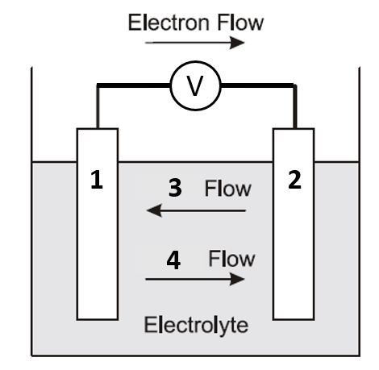
The labels in order 1, 2, 3, 4 are:
A. | Cathode (-), anode (+), anion, cation
B. | Cathode (-), Anode (+), cation, anion
C. | Anode (-), Cathode (+), anion, cation
D. | Anode (-), Cathode (+), cation, anion

Use the following information for Questions 8 and 9
The lead-acid accumulator (car battery) is a well-known example of a secondary cell. The battery consists of six separate cells connected in series. The overall equation for the reaction during discharge is:
Pb (s) + PbO₂ (s) + 2 H₂SO₄ (aq) 2 PbSO₄ (s) + 2 H₂O (l)
Question 8
Which of the following half equations represents the oxidation reaction that occurs at the anode during recharging of the car battery
A. | Pb (s) + SO₄²⁻ (aq) PbSO₄ (s) +2e⁻
B. | PbSO₄ (s) +2e⁻ Pb (s) + SO₄²⁻ (aq)
C. | PbO₂ (s) + 4 H⁺ (aq) + SO₄²⁻ (aq) + 2e⁻ 2 H₂O (l) + PbSO₄ (s)
D. | 2 H₂O (l) + PbSO₄ (s) PbO₂ (s) + 4 H⁺ (aq) + SO₄²⁻ (aq) + 2e⁻

Question 9
Which of the following features of the lead-acid battery enables it to function as a secondary cell?
A. | During recharging, additional reactions may occur.
B. | The products of the electrode reactions adhere to the electrodes
C. | The electrolyte used is approximately 4M H₂SO₄ solution
D. | Contact between the electrodes is prevented by the presence of a porous separator

Question 10
A metal cup containing a 90.0g of water was placed over a burning paraffin candle. After some time, the change in temperature of the water was recorded, as well as the mass of the paraffin that was burned and the heat of combustion of the paraffin in the candle was calculated as -10.9 kJ/g. Which of the following statements about this experiment is true?
A. | If ΔT of the water was found to be 19.5˚C, then the energy gained by the water would be calculated as 8151 J.  Energy = 90.0 x 4.18 x 19.5 = 7335.9
B. | This experimental value for the heat of combustion of paraffin would be lower than the actual due to heat that is lost to the surrounding air.
C. | The energy that is absorbed by the metal cup would have no effect on the experimental value that was calculated.
D. | In order to calculate the heat of combustion, the value for the energy gained by the water should be multiplied (should be divided) by the mass of the paraffin that was burned.

Question 11
2.6 g ethene underwent complete combustion. The energy released was used to heat 2.34 kg of water with an initial temperature of 26 ˚C. Assuming that no heat was lost, the temperature of the water would have increased by:
A. | n(ethene) = 2.6 g ÷28 g/mol = 0.09286 mol  E_{absorbed by water} = E _{released by ethene} = 0.09286 mol x 1409 kJ/mol  ΔT = E_{absorbed by water} ÷(m(H₂O) x c(H₂O))  ΔT = 130.836 x 10³ J ÷ (2.34 x10³ g x 4.18 J/g/˚C) = 13.4 ˚C
B. | n(ethane) = 2.6 g ÷28 g/mol = 0.09286 mol  E_{absorbed by water} = E _{released by ethane} = 0.09286 mol x 1409 kJ/mol  ΔT = E_{absorbed by water} ÷(m(H₂O) x c(H₂O))  ΔT = 130.836 kJ ÷ (2.34 x10³ g x 4.18 J/g/˚C) = 0.0134 ˚C
C. | n(ethane) = 2.6 g ÷28 g/mol = 0.09286 mol  E_{absorbed by water} = E _{released by ethane} = 0.09286 mol x 1409 kJ/mol  ΔT = E_{absorbed by water} ÷(m(H₂O) x c(H₂O))  ΔT = 130.836 x 10³ J ÷ (2.34 kg x 4.18 J/g/˚C) = 1.34 x 10⁴ ˚C
D. | Calculate final temperature instead of change in temp = 39.4 ˚C

Question 13
Which of the following would be predicted to spontaneously reduce aqueous Pb²⁺ ions, but not spontaneously reduce aqueous Co²⁺ ions?
A. | Ni²⁺ (aq)
B. | Sn (s)
C. | H⁺ (aq)
D. | Fe (s)

Section B - Short answer Questions
Question 1 (6 marks)
A 2.15 g sample of peanuts is burned. The heat released raises the temperature of a 100.0 g sample of water from 18.2 to 31.5 ˚C. The mass of the sample of peanuts after the experiment is 1.78 g. The water was only able to absorb 25.0% of the heat released by the burning peanuts.

- Draw a labelled diagram to show how this experiment may have been set up.
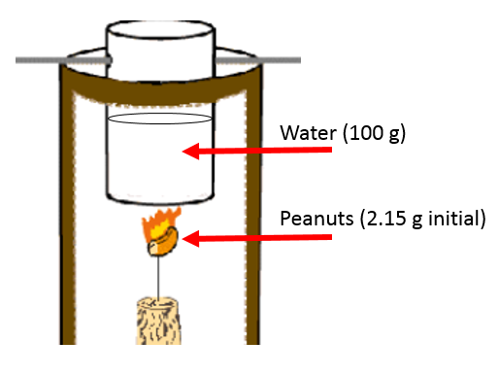
- diagram shows peanuts heating sample of water using an experimental set-up with no insulation (1 mark)
- Water (100 g) and peanuts (2.15 g initial) are clearly labelled (1 mark)

2 marks

- Assuming that 1.00 calorie (Cal) is equal to 4.18 kJ:

- Calculate the energy, in calories, that was absorbed by the water.
Energy absorbed by the water = m c ΔT
= 100.0 g x 4.18 J/g/˚C x (31.5 – 18.2 ˚C) = 5559.4 J
Convert energy to calories 5559.4 x 10⁻³ kJ x (1.00 Cal ÷ 4.18 kJ)
= 1.33 Cal
- Calculate the calorie content of the peanuts in Cal/g.
25% of the energy from the peanuts was absorbed by the water therefore the calories released by 0.37 g of peanuts
= 1.33 Cal ÷ 0.25 = 5.32 Cal
∴ Calorie content = 5.32 Cal ÷ 0.37 g = 14.3784 = 14.4 Cal/g
2 + 2 = 4 marks

Question 2 (8 marks)
A student constructed two electrochemical cells as shown below.
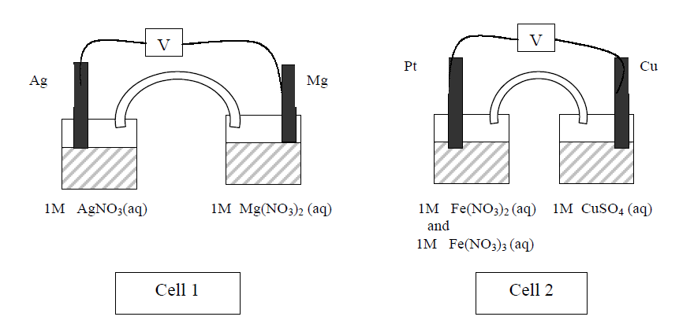
- Use equations to describe the changes that occur in each half cell of cell 1 as the cell operates.
Mg (s) Mg²⁺ (aq) + 2e⁻ (1 mark)
Magnesium undergoes oxidation and will slowly dissolve. Its mass will decrease. (1 mark)
Ag+(aq) + e  Ag (s) (1 mark)
Silver metal is deposited over the top of the silver electrode. (1 mark) It will increase in mass.
4 marks
- In cell 2, the solution in one half cell is initially orange due to the mixture of pale green Fe²⁺ and orange Fe³⁺ ions. The other half cell is blue due to the Cu²⁺ ions. Describe the colour changes the student would see in each half-cell of cell 2 if the reaction proceeded until no further changes took place.
The copper sulfate half-cell will become a darker blue due to production of Cu²⁺ ions (1 mark)
Cu(s) Cu²⁺(aq) + 2e⁻
The other half cell will become pale green due to the production of Fe²⁺ ions. (1 mark)
Fe³⁺(aq) + e⁻ Fe²⁺(aq)
2 marks
- What is the purpose of the salt bridge joining each half cell?
It completes the circuit. (1 mark) The electrolyte in the salt bridge provides charge to balance to each half cell by allowing ions to migrate. (1 mark) Anions move to the anode side, cations move to the cathode side.
2 marks

Question 3 (7 marks)
Proton exchange membrane (PEM) (or “solid polymer”) fuel cells react hydrogen with oxygen and use an electrolyte that is composed of a solid polymer film that consists of a form of acidified Teflon. PEM fuel cells typically operate at 70 to 90 ºC.
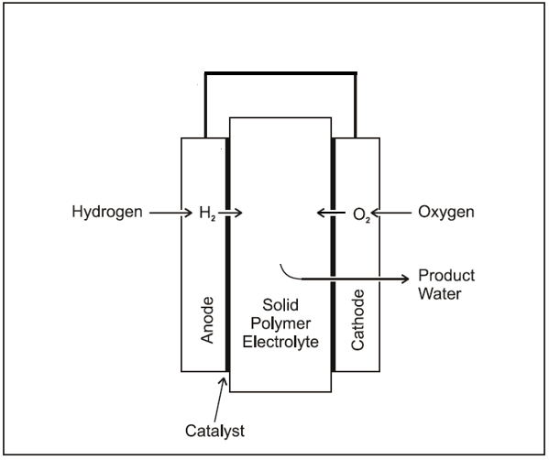
- Explain why the following statement is considered as an advantage of PEM fuel cells:
- The PEM fuel cell operates at low temperatures and pressures

This simplifies material issues, provides for quick start-up and increses safety, can be used in regular households/environments (one valid point only required)
1 mark
- On the diagram above, use an arrow to indicate the direction of electron flow in the cell when it is producing energy.
1 mark
- PEM fuel cells can also run using methanol fuel directly. These type of cells are supplied with liquid methanol and water at the anode, and air or oxygen gas at the cathode. An acidic electrolyte is present in the cell.

- Methanol is converted to carbon dioxide and H⁺ ions at the anode.
Write an equation for this reaction.
CH₃OH (l) or (aq) + H₂O (l) 6 H⁺ (aq) + CO₂ (g) + 6 e⁻
1 mark for balanced half-equation, 1 mark for states and single arrow (not double)
- At the cathode oxygen, from the air, ionizes and reacts with hydrogen ions to form water. Combine the anode and cathode reactions to write an overall cell reaction for the direct methanol PEM fuel cell.
At the cathode: O₂ (g) + 4H⁺ (aq) + 4 e⁻ 2 H₂O (l)
Overall: 2 CH₃OH (aq) + 3 O₂ (g) 2 CO₂ (g) + 4 H₂O (l)

2 marks for balanced overall equation, although the reduction half-equation is needed to write the overall, do not penalise if it is not shown.
2 + 2 = 4 marks

- Describe one disadvantage of the direct PEM compared with the standard PEM fuel cell.
Disadvantage: CO₂ gas is a product of the direct cell which is not as sustainable

1 mark

Question 4 (6 marks)
A solution of an iron salt is electrolysed in a cell by passing 0.22 A through the cell for 1.5 hours. The mass of iron metal deposited on one electrode was 0.343 g.

- i. State the name and polarity (positive or negative) of the electrode at which the iron metal was deposited.
Cathode, negative
1 mark
- i. Calculate the amount (in mol) of iron deposited.
n (Fe) = m ÷ M = 0.343 g ÷ 55.8 g/mol = 0.006146 = 6.15 x 10⁻³ mol
ii. Calculate the amount (in mol) of electrons used to deposit the iron.
n (e⁻) = (I x t) ÷ F = (0.22 A x 1.5 x 60 x 60 s) ÷ 96 500 = 0.01231 = 1.2 x 10⁻² mol

ii. Hence calculate the charge on the iron ion in the salt.
n (e⁻) : n (Fe) = 0.01231 : 0.006146 = 2 : 1
The charge is therefore +2 and the ion is Fe²⁺
1 + 1 + 1 = 3 marks

- Explain why it is not possible to deposit potassium by the electrolysis of a potassium salt solution.
Water is a stronger oxidant than the potassium ion (1 mark)
Water would therefore be reduced to form hydrogen and hydroxide, and the potassium ion would not react to produce potassium. (1 mark)
2 marks
Question 5 (3 marks)
The combustion of 1.50 g of aluminium powder, Al (s) in oxygen releases 46.5 kJ of energy
Write a balanced thermochemical equation to represent this reaction.
Balanced equation for the combustion reaction: (1 mark including states)
4 Al (s) + 3 O₂ (g) 2 Al₂O₃ (s)

To calculate ΔH: (1 mark for value)
n (Al) = m ÷ M = 1.5 g ÷ 27 g/mol = 0.05556 mol
Therefore for 4 mol of aluminium (from equation)
E released = 4mol (46.5 kJ ÷ 0.05556 mol) = 3348 kJ

Therefore the thermochemical equation: (1 mark for equation with negative ΔH value and correct units)
4 Al (s) + 3 O₂ (g) 2 Al₂O₃ (s) ΔH = -3348 kJ mol⁻¹

Question 6 (6 marks)
In order to determine the experimental value for the heat of fusion (J g⁻¹) of ice, a group of chemistry students placed a 25.8 g sample of ice into a paper coffee cup with 100.0 g of water at 35.4 ˚C. They placed a lid on the cup and inserted a thermometer (Experiment 1). After several minutes the ice completely melted and the water temperature had lowered to 18.1 ˚C.
The students then repeated the experiment (Experiment 2) with the following changes:
- They used a calorimeter instead of a coffee cup (masses of ice and water were the same)
- Before conducting the experiment they passed a current of 1150 mA at 5.84 V through the electric heater in the calorimeter and noted a temperature rise of 1.16 ˚C in 63 seconds

- What was the student’s experimental value for the heat of fusion (J g⁻¹) of ice in Experiment 1?
The quantity of energy lost by the water when cooling is assumed to be equal to the quantity of energy required to melt the ice.
E(J) = m c ΔT = 100 g x 4.18 J/g/˚C x (18.1 – 35.4 ˚C) = 7231.4 J
25.8 g ice absorbed 7231.4 J
∴ heat of fusion (ice) = 7231.4 J ÷ 25.8 g = 2.80 x 10² J/g
2 marks
- What was the calibration factor for the calorimeter used in Experiment 2?
CF = VIt ÷ ΔT
= (5.84 V x 1150 x 10⁻³ A x 63 s) ÷ 1.16 ˚C = 364.7 = 3.6 x 10² J/g/ ˚C
*1 mark correct to 2 significant figures with units
2 marks

- Provide an explanation to support whether you believe the value calculated for the heat of fusion of ice in Experiment 2 would have been bigger, smaller, or the same as the value calculated in Experiment 1.
If the student assumes that the external environment is colder than the internal environment (initial temp of water is 35.4 ˚C)
- A smaller ΔT would be recorded in Experiment 2 than in Experiment 1 as insulation in calorimeter would prevent heat lost by water to the surroundings (1 mark)
- This would result in a smaller calculated energy value and thus a smaller value for the heat of fusion of ice in Experiment 2. (1 mark)

Or
If the student assumes that the external environment is hotter than the internal environment (initial temp of water is 35.4 ˚C)
- A larger ΔT would be recorded in Experiment 2 than in Experiment 1 as insulation in calorimeter would prevent heat gained by water from the surroundings (1 mark)
- This would result in a larger calculated energy value and thus a larger value for the heat of fusion of ice in Experiment 2. (1 mark)

2 marks

END OF QUESTION AND ANSWER BOOKLET

